**Project 4: ExpressFood Uml Diagram**



**Textual Use case**

**Client Use Cases**

|  |  |
| --- | --- |
| **Use case** | Check menu Use case |
| **Use case name** | Check menu |
| **Use case description** | Check menu is the ability to request the system for menu details |
| **Actor** | Client |
| **Pre-condition** | Client want to select dish |
| **Basic flow** | 1. Client selects the view menu option 2. System displays the menu card 3. Client select which dish he wish to buy 4. System displays options to place order |
| **Post-condition** | Check menu class has been created |
| **Altenate flow** | * Menu card unavailable. * System does not respond when view menu is requested. |

|  |  |
| --- | --- |
| **Use case** | Place order Use case |
| **Use case name** | Place order |
| **Use case description** | Place order is the ability to place order for dish |
| **Actor** | Client |
| **Pre-condition** | Client want to place order for dish |
| **Basic flow** | 1. Client select dish and dessert 2. System requests for client personal information 3. Client enters details. 4. System verifies the information. 5. System request order to be submitted. 6. Systems sends confirmation of order gone for delivery and estimate of meal arrival time. |
| **Post-condition** | Order has been created |
| **Altenate flow** | * Dish requested not in stock. * Dish has been discontinued. * Payment failed. * Delivery exceeds 20minutes. |

**Chef Use Cases**

|  |  |
| --- | --- |
| **Use case** | Check menu Use case |
| **Use case name** | Check menu |
| **Use case description** | Check menu is the ability to request the system for menu details |
| **Actor** | Chef |
| **Pre-condition** | Chef want to check menu items |
| **Basic flow** | 1. Client selects the view menu option 2. System displays the menu card 3. Chef select which dish he wish to check |
| **Post-condition** | Check menu class has been created |
| **Altenate flow** | * Menu card unavailable. * System does not respond when view menu is requested. |

|  |  |
| --- | --- |
| **Use case** | Update menu Use case |
| **Use case name** | Update menu items |
| **Use case description** | Update menu item is the ability to request the system for menu details |
| **Actor** | Chef |
| **Pre-condition** | Chef wants to update the menu items |
| **Basic flow** | 1. Chef select view menu card 2. System displays the menu card 3. Client select which dish he will update 4. System displays options to change the details menu item |
| **Post-condition** | Change menu item has been created |
| **Altenate flow** | * Menu card unavailable. * System does not update the menu when changes have been made. * Dish is unavailable. |

**Delivery Biker Use case**

|  |  |
| --- | --- |
| **Use case** | Receive order |
| **Use case name** | Receive order |
| **Use case description** | Receive order is to start the delivery process |
| **Actor** | Delivery biker |
| **Pre-condition** | Delivery is being requested |
| **Basic flow** | 1. Delivery biker receives an order 2. Delivery biker accepts the delivery process 3. System sends a delivery estimate to client. |
| **Post-condition** | Delivery process has started. |
| **Altenate flow** | * Client address and details are missing. * Client has changed address. * System cannot update order confirmation for delivery estimate |



**The MySQL database with information filed up.**

Database for expressfood has been created with its different tables for clients’ records.

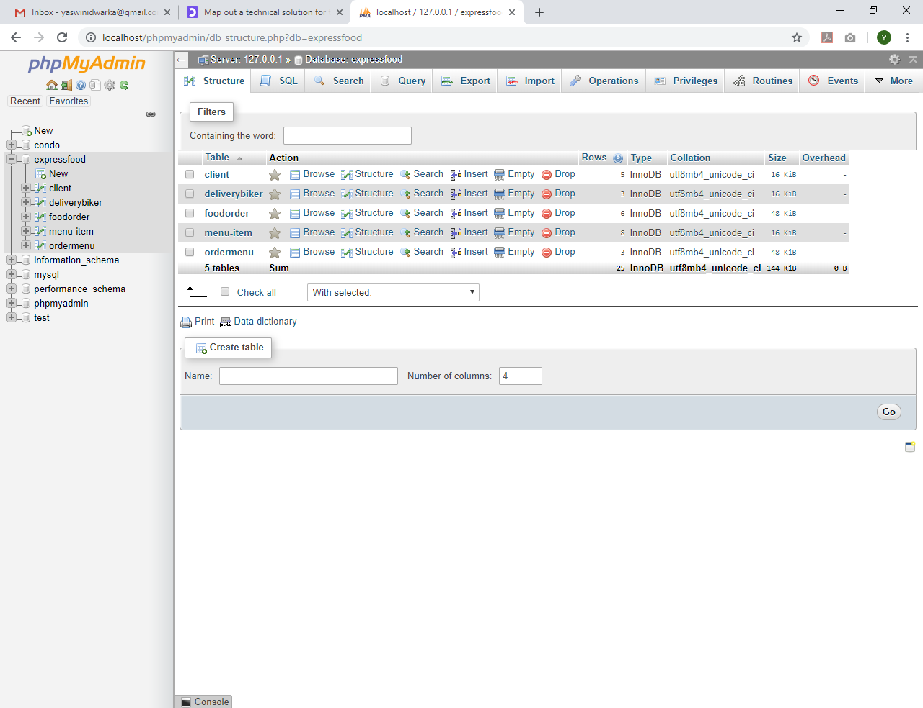

1. **A list of clients.**

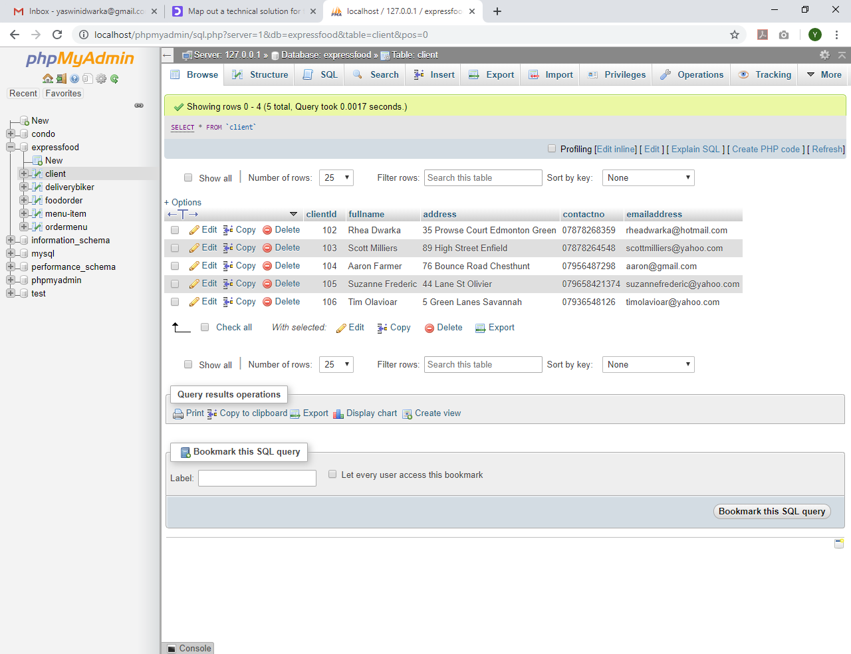

**2. - A List for different daily menu items.**

In SQL tab, sql query is written to return a list of menu items for the day 01-03-2019 and 02-03-2019 are as follows

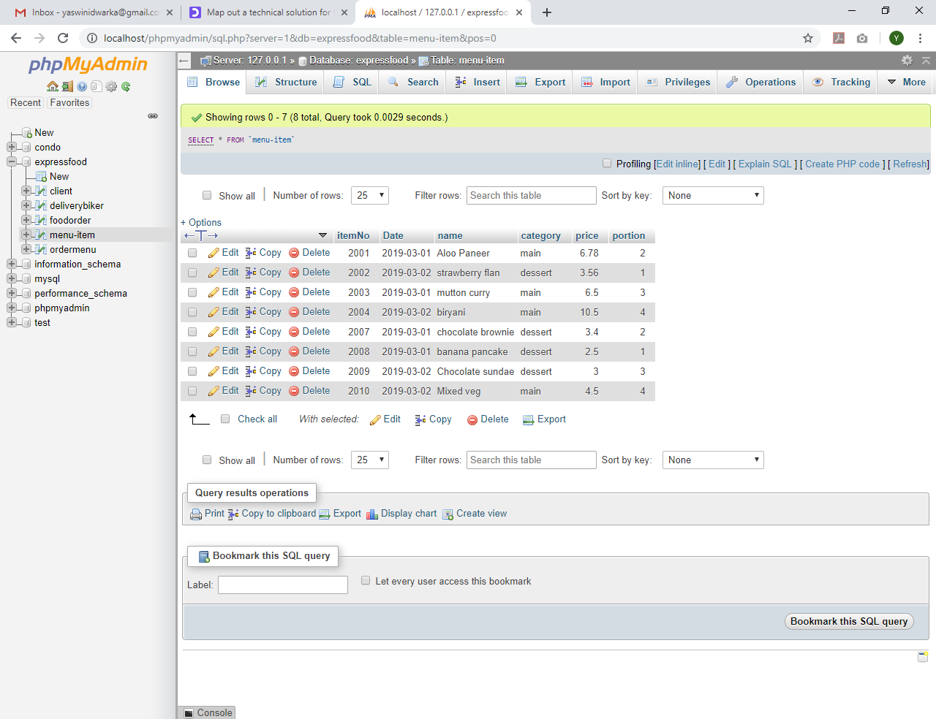

[SELECT](http://localhost/phpmyadmin/url.php?url=https://dev.mysql.com/doc/refman/5.5/en/select.html) * FROM `menu-item` where [Date](http://localhost/phpmyadmin/url.php?url=https://dev.mysql.com/doc/refman/5.5/en/date-and-time-types.html) = '2019-03-01';

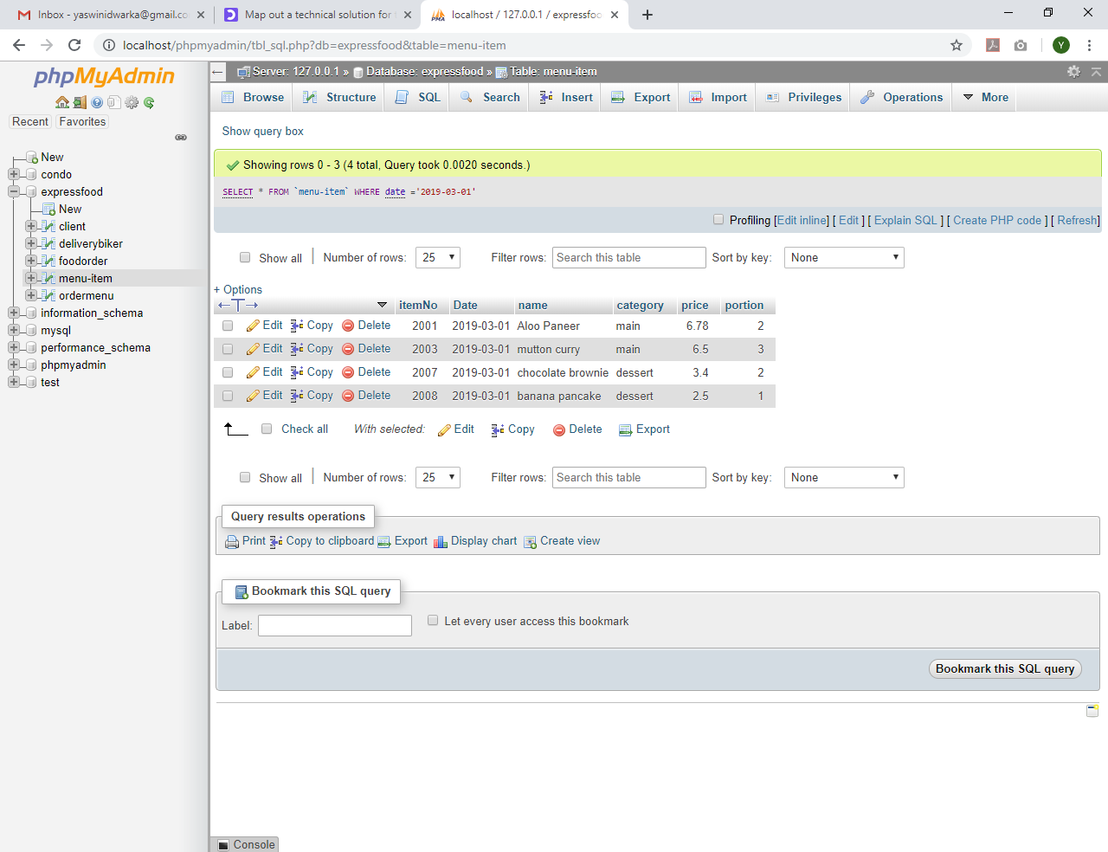

[SELECT](http://localhost/phpmyadmin/url.php?url=https://dev.mysql.com/doc/refman/5.5/en/select.html) * FROM `menu-item` where [Date](http://localhost/phpmyadmin/url.php?url=https://dev.mysql.com/doc/refman/5.5/en/date-and-time-types.html) = '2019-03-02’;

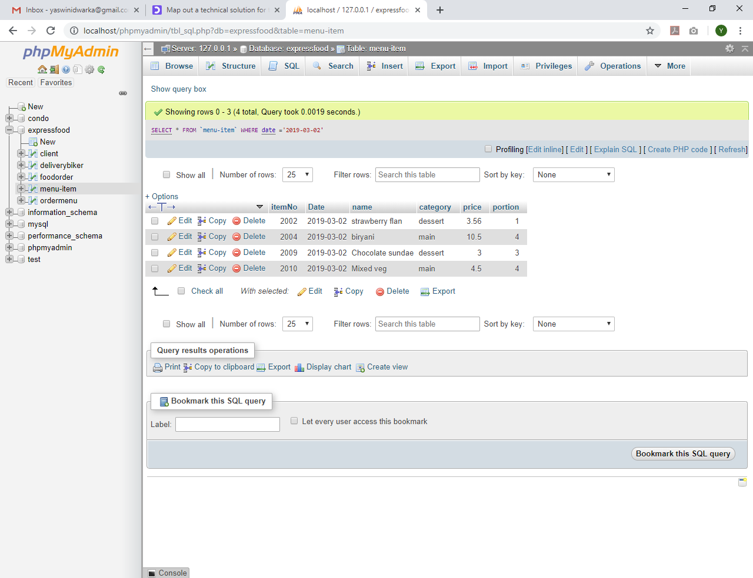

**3.- A list of delivery people**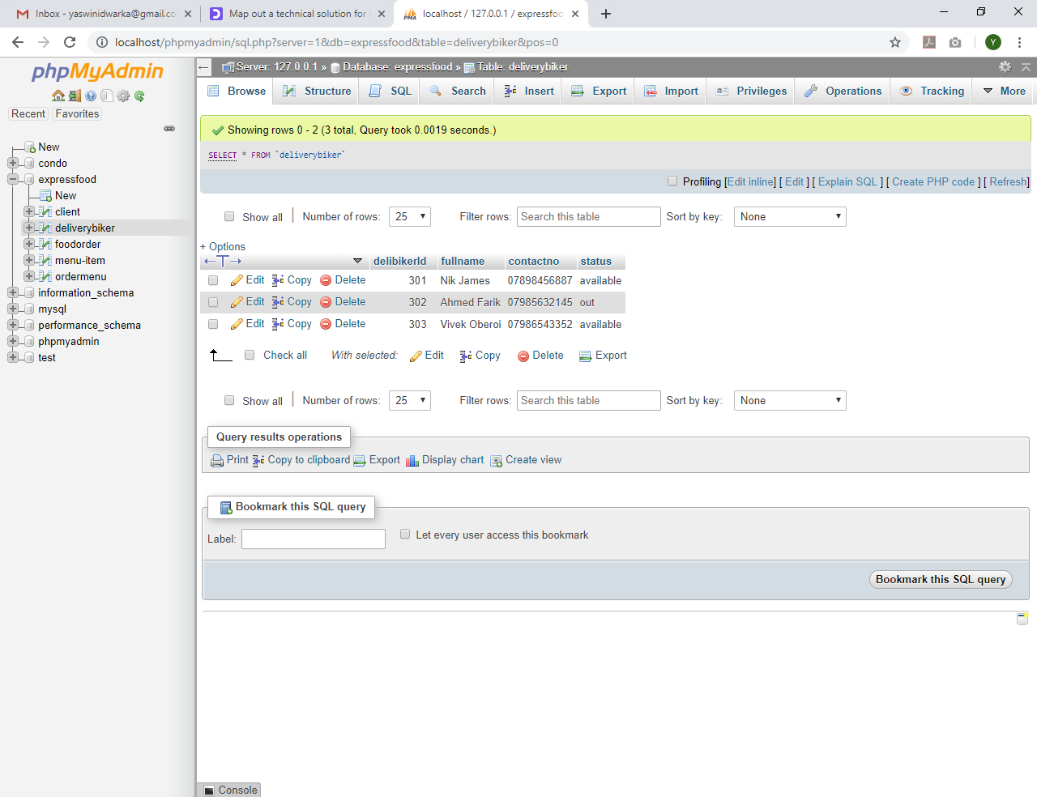

**4.- An order history for each client**

Sql query that returns a list of orders placed by clientId 104

[SELECT](http://localhost/phpmyadmin/url.php?url=https://dev.mysql.com/doc/refman/5.5/en/select.html) * FROM `foodorder` WHERE clientId ='104';

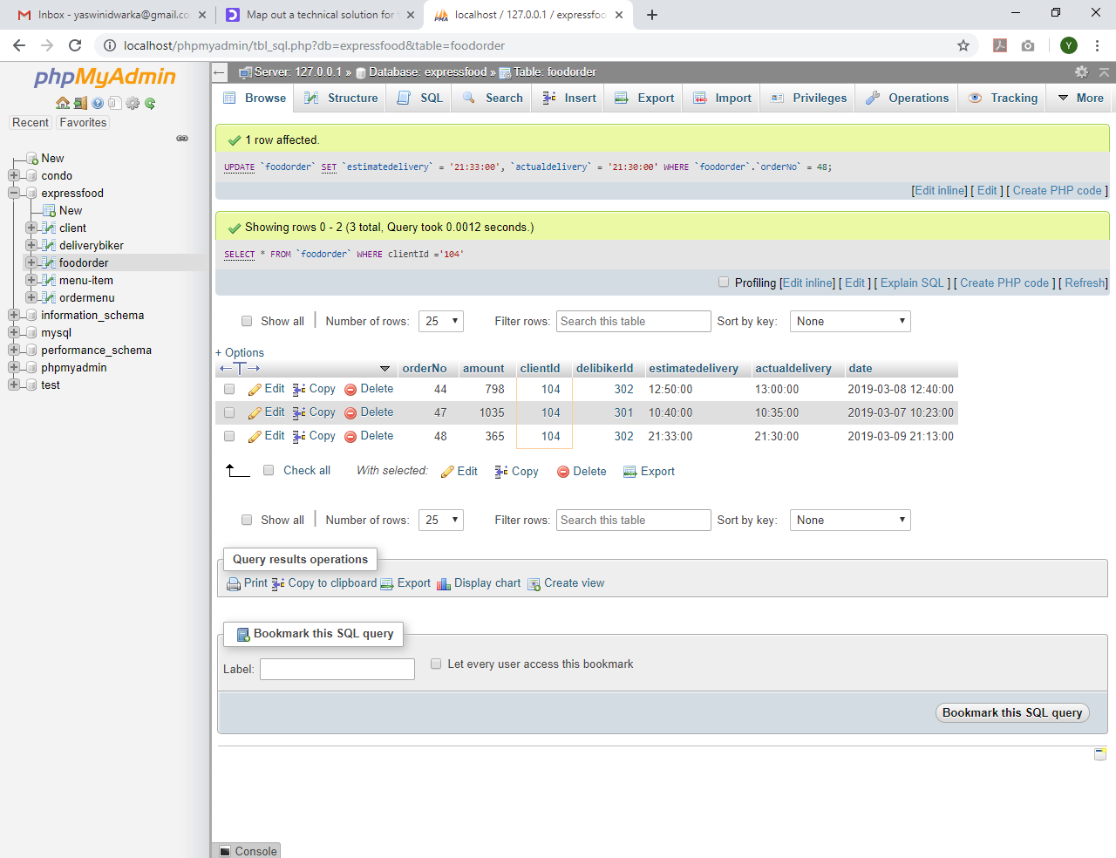

Consideration is given on the estimate delivery time and actual delivery time and the time ordered. All the orders should be delivered within 20minutes.